1. **NOTE**: There are several methods to perform insertion.   
   All those methods are collection methods. It means that those methods must be performed on a collection.
2. 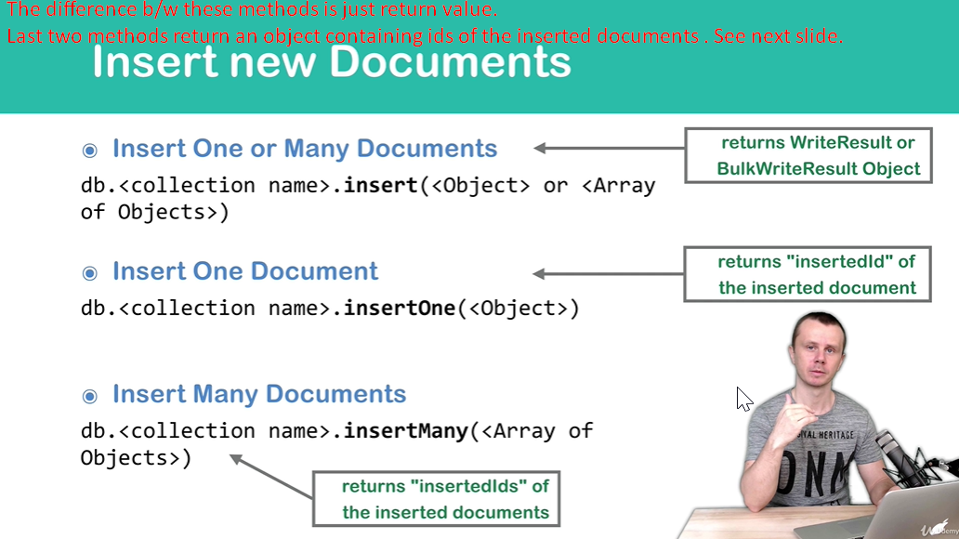
3. 